**PL/SQL HANDS ON:**

**Exercise 1: Control Structures**

**Scenario 1:** The bank wants to apply a discount to loan interest rates for customers above 60 years old.

**Question:** Write a PL/SQL block that loops through all customers, checks their age, and if they are above 60, apply a 1% discount to their current loan interest rates.

**COMMANDS:**

SET SERVEROUTPUT ON;

DELETE FROM Customers WHERE CustomerID = 999;

DELETE FROM Loans WHERE CustomerID = 999;

INSERT INTO Customers (CustomerID, Name, DOB, Balance, LastModified)

VALUES (999, 'Senior Citizen', TO_DATE('1950-01-01', 'YYYY-MM-DD'), 5000, SYSDATE);

INSERT INTO Loans (LoanID, CustomerID, LoanAmount, InterestRate, StartDate, EndDate)

VALUES (999, 999, 10000, 7, SYSDATE, ADD_MONTHS(SYSDATE, 24));

BEGIN

  FOR rec IN (

    SELECT c.CustomerID, c.Name, c.DOB, l.LoanID, l.InterestRate

    FROM Customers c

    JOIN Loans l ON c.CustomerID = l.CustomerID

  ) LOOP

    IF TRUNC(MONTHS_BETWEEN(SYSDATE, rec.DOB)/12) > 60 THEN

      UPDATE Loans

      SET InterestRate = InterestRate - 1

      WHERE LoanID = rec.LoanID;

      DBMS_OUTPUT.PUT_LINE('Discount applied to: ' || rec.Name ||

                           ' | New Interest Rate Applied.');

    ELSE

      DBMS_OUTPUT.PUT_LINE('No discount: ' || rec.Name);

    END IF;

  END LOOP;

  COMMIT;

END;

/

**OUTPUT:**

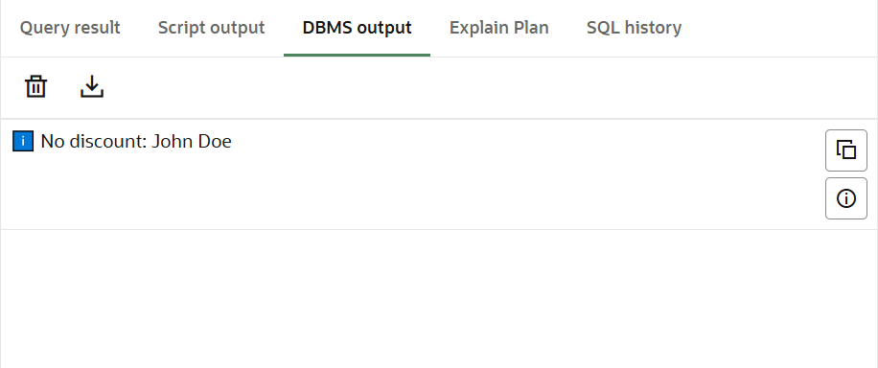

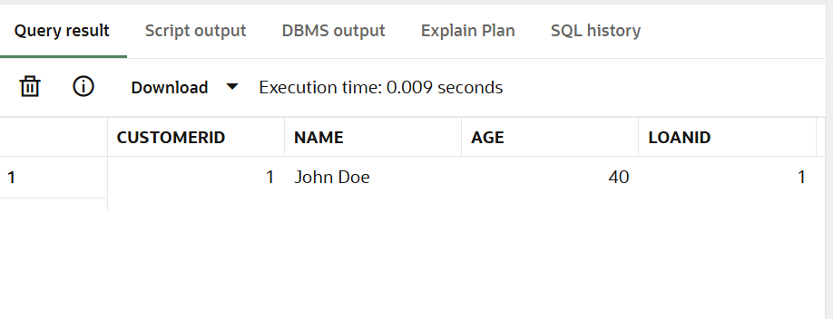

**Scenario 2:** A customer can be promoted to VIP status based on their balance.

**Question:** Write a PL/SQL block that iterates through all customers and sets a flag IsVIP to TRUE for those with a balance over $10,000.

**COMMANDS:**

SET SERVEROUTPUT ON;

BEGIN

  FOR rec IN (

    SELECT CustomerID, Name, Balance, IsVIP FROM Customers

  ) LOOP

    IF rec.Balance > 10000 THEN

      UPDATE Customers

      SET IsVIP = 'TRUE'

      WHERE CustomerID = rec.CustomerID;

      DBMS_OUTPUT.PUT_LINE(' VIP status granted to: ' || rec.Name ||

                           ' | Balance: $' || rec.Balance);

    ELSE

      DBMS_OUTPUT.PUT_LINE(' Not eligible for VIP: ' || rec.Name ||

                           ' | Balance: $' || rec.Balance);

    END IF;

  END LOOP;

  COMMIT;

END;

/

**OUTPUT:**

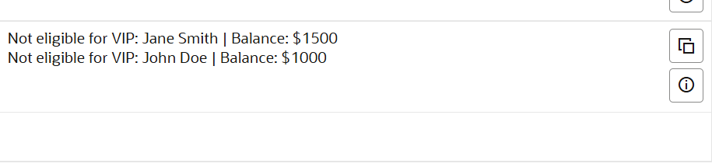

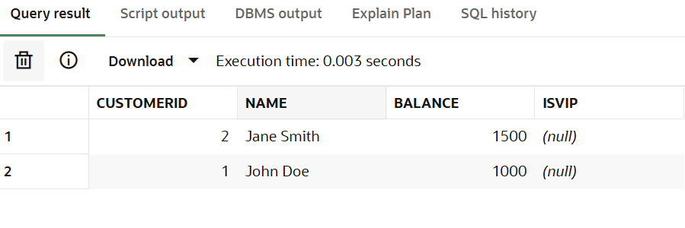

**Scenario 3:** The bank wants to send reminders to customers whose loans are due within the next 30 days.

**Question:** Write a PL/SQL block that fetches all loans due in the next 30 days and prints a reminder message for each customer.

**COMMANDS:**

BEGIN

  FOR loan_rec IN (

    SELECT l.LoanID, c.Name, c.CustomerID

    FROM Loans l

    JOIN Customers c ON l.CustomerID = c.CustomerID

    WHERE l.EndDate BETWEEN SYSDATE AND SYSDATE + 30

  )

  LOOP

    DBMS_OUTPUT.PUT_LINE('Reminder: Customer ' || loan_rec.Name ||

                         ' (ID: ' || loan_rec.CustomerID ||

                         ') has loan ' || loan_rec.LoanID ||

                         ' due within 30 days.');

  END LOOP;

END;

/

**OUTPUT:**

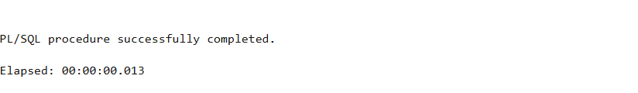

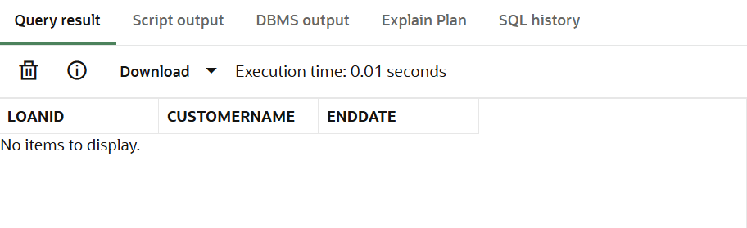

**Exercise 2: Error Handling**

**Scenario 1:** Handle exceptions during fund transfers between accounts.

**Question:** Write a stored procedure **SafeTransferFunds** that transfers funds between two accounts. Ensure that if any error occurs (e.g., insufficient funds), an appropriate error message is logged and the transaction is rolled back.

**COMMANDS:**

CREATE OR REPLACE PROCEDURE SafeTransferFunds(

  p_from_acc NUMBER,

  p_to_acc NUMBER,

  p_amount NUMBER

) AS

  v_balance NUMBER;

BEGIN

  SELECT Balance INTO v_balance FROM Accounts WHERE AccountID = p_from_acc;

  IF v_balance < p_amount THEN

    DBMS_OUTPUT.PUT_LINE(' Insufficient funds in Account ' || p_from_acc);

  ELSE

    UPDATE Accounts SET Balance = Balance - p_amount WHERE AccountID = p_from_acc;

    UPDATE Accounts SET Balance = Balance + p_amount WHERE AccountID = p_to_acc;

    DBMS_OUTPUT.PUT_LINE(' Transferred ' || p_amount || ' from Account ' || p_from_acc || ' to Account ' || p_to_acc);

    COMMIT;

  END IF;

EXCEPTION

  WHEN NO_DATA_FOUND THEN

    DBMS_OUTPUT.PUT_LINE(' Account not found.');

  WHEN OTHERS THEN

    DBMS_OUTPUT.PUT_LINE(' Error: ' || SQLERRM);

    ROLLBACK;

END;

/

SET SERVEROUTPUT ON;

BEGIN

  SafeTransferFunds(1, 2, 200);

END;

/

SELECT * FROM Accounts;

**OUTPUT :**

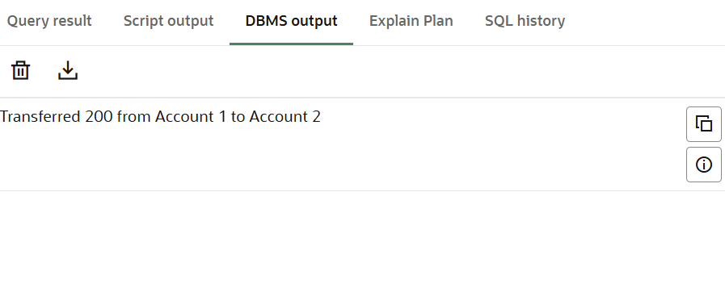

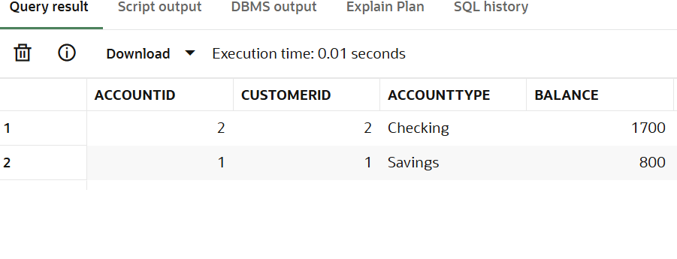

**Scenario 2:** Manage errors when updating employee salaries.

**Question:** Write a stored procedure **UpdateSalary** that increases the salary of an employee by a given percentage. If the employee ID does not exist, handle the exception and log an error message.

**COMMANDS:**

CREATE OR REPLACE PROCEDURE UpdateSalary(

  p_emp_id NUMBER,

  p_percent NUMBER

) AS

BEGIN

  UPDATE Employees

  SET Salary = Salary + (Salary * p_percent / 100)

  WHERE EmployeeID = p_emp_id;

  IF SQL%ROWCOUNT = 0 THEN

    DBMS_OUTPUT.PUT_LINE(' Employee ID ' || p_emp_id || ' not found.');

  ELSE

    DBMS_OUTPUT.PUT_LINE(' Salary updated for Employee ID ' || p_emp_id);

  END IF;

  COMMIT;

EXCEPTION

  WHEN OTHERS THEN

    DBMS_OUTPUT.PUT_LINE(' Error: ' || SQLERRM);

    ROLLBACK;

END;

/

SET SERVEROUTPUT ON;

BEGIN

 UpdateSalary(1, 10);

END;

/

SELECT * FROM Employees WHERE EmployeeID = 1;

**OUTPUT :**



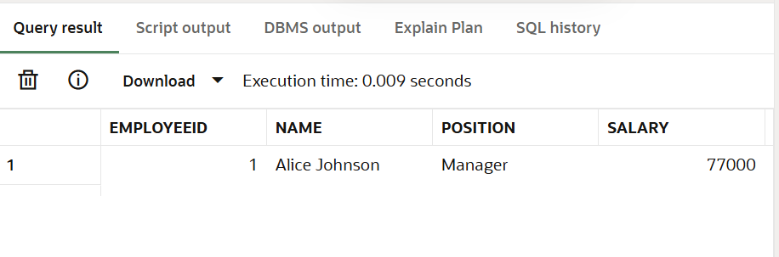

**Scenario 3:** Ensure data integrity when adding a new customer.

**Question:** Write a stored procedure **AddNewCustomer** that inserts a new customer into the Customers table. If a customer with the same ID already exists, handle the exception by logging an error and preventing the insertion.

**COMMANDS:**

CREATE OR REPLACE PROCEDURE AddNewCustomer(

  p_id NUMBER,

  p_name VARCHAR2,

  p_dob DATE,

  p_balance NUMBER

) AS

BEGIN

  INSERT INTO Customers(CustomerID, Name, DOB, Balance, LastModified)

  VALUES (p_id, p_name, p_dob, p_balance, SYSDATE);

  DBMS_OUTPUT.PUT_LINE(' Customer added: ' || p_name);

  COMMIT;

EXCEPTION

  WHEN DUP_VAL_ON_INDEX THEN

    DBMS_OUTPUT.PUT_LINE(' Customer ID ' || p_id || ' already exists.');

    ROLLBACK;

  WHEN OTHERS THEN

    DBMS_OUTPUT.PUT_LINE(' Error: ' || SQLERRM);

    ROLLBACK;

END;

/

SET SERVEROUTPUT ON;

BEGIN

  AddNewCustomer(999, 'Test User', TO_DATE('1990-01-01', 'YYYY-MM-DD'), 5000);

END;

/

SELECT * FROM Customers WHERE CustomerID = 999;

**OUTPUT:**

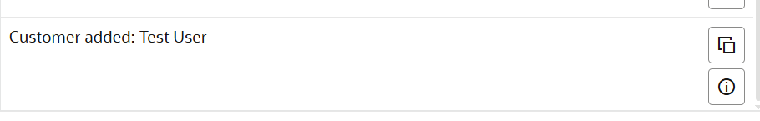

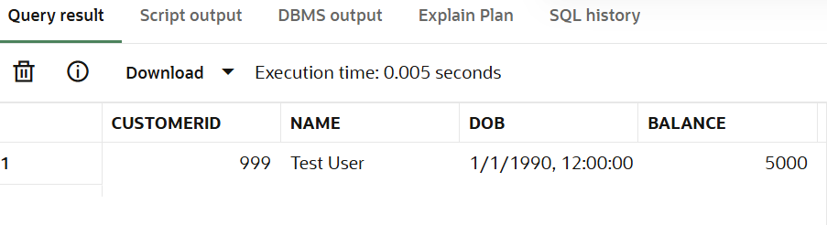

**Exercise 3: Stored Procedures**

**Scenario 1:** The bank needs to process monthly interest for all savings accounts.

**Question:** Write a stored procedure **ProcessMonthlyInterest** that calculates and updates the balance of all savings accounts by applying an interest rate of 1% to the current balance.

**COMMANDS:**

CREATE OR REPLACE PROCEDURE ProcessMonthlyInterest IS

BEGIN

  FOR acc_rec IN (

    SELECT AccountID, Balance

    FROM Accounts

    WHERE AccountType = 'Savings'

  ) LOOP

    UPDATE Accounts

    SET Balance = Balance + (acc_rec.Balance * 0.01)

    WHERE AccountID = acc_rec.AccountID;

    DBMS_OUTPUT.PUT_LINE(' Interest applied to Account ID: ' || acc_rec.AccountID);

  END LOOP;

  COMMIT;

END;

/

SET SERVEROUTPUT ON;

BEGIN

  ProcessMonthlyInterest;

END;

/

SELECT * FROM Accounts WHERE AccountType = 'Savings';

**OUTPUT**

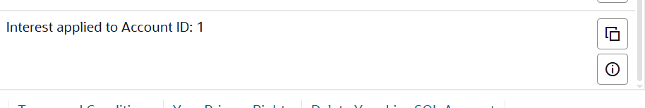

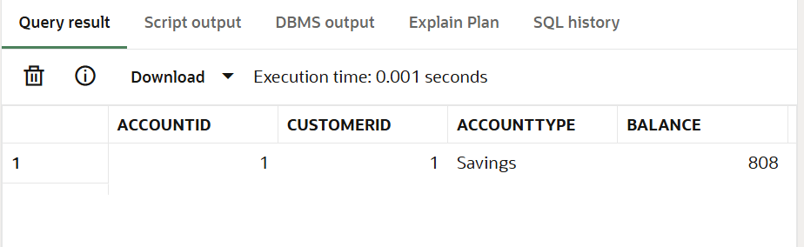

**Scenario 2:** The bank wants to implement a bonus scheme for employees based on their performance.

**Question:** Write a stored procedure **UpdateEmployeeBonus** that updates the salary of employees in a given department by adding a bonus percentage passed as a parameter.

**COMMANDS:**

CREATE OR REPLACE PROCEDURE UpdateEmployeeBonus(

  p_dept VARCHAR2,

  p_bonus_percent NUMBER

) IS

BEGIN

  FOR emp_rec IN (

    SELECT EmployeeID, Salary FROM Employees WHERE Department = p_dept

  ) LOOP

    UPDATE Employees

    SET Salary = Salary + (Salary * p_bonus_percent / 100)

    WHERE EmployeeID = emp_rec.EmployeeID;

    DBMS_OUTPUT.PUT_LINE(' Bonus added to Employee ID: ' || emp_rec.EmployeeID);

  END LOOP;

  COMMIT;

END;

/

SET SERVEROUTPUT ON;

BEGIN

  UpdateEmployeeBonus('IT', 10);

END;

/

SELECT * FROM Employees WHERE Department = 'IT';

OUTPUT:



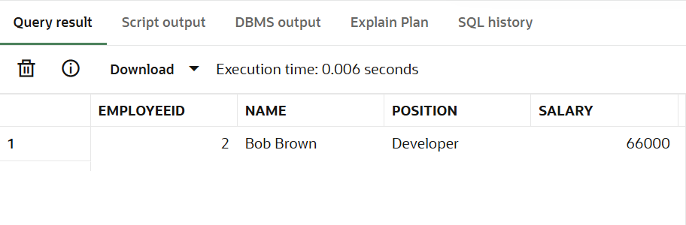

**Scenario 3:** Customers should be able to transfer funds between their accounts.

**Question:** Write a stored procedure **TransferFunds** that transfers a specified amount from one account to another, checking that the source account has sufficient balance before making the transfer.

**COMMANDS:**

CREATE OR REPLACE PROCEDURE TransferFunds(

  p_from_acc NUMBER,

  p_to_acc NUMBER,

  p_amount NUMBER

) IS

  v_balance NUMBER;

BEGIN

  SELECT Balance INTO v_balance FROM Accounts WHERE AccountID = p_from_acc;

  IF v_balance < p_amount THEN

    DBMS_OUTPUT.PUT_LINE(' Insufficient balance in Account ID: ' || p_from_acc);

  ELSE

    UPDATE Accounts SET Balance = Balance - p_amount WHERE AccountID = p_from_acc;

    UPDATE Accounts SET Balance = Balance + p_amount WHERE AccountID = p_to_acc;

    DBMS_OUTPUT.PUT_LINE(' Transferred ' || p_amount || ' from Account ' || p_from_acc || ' to Account ' || p_to_acc);

    COMMIT;

  END IF;

EXCEPTION

  WHEN NO_DATA_FOUND THEN

    DBMS_OUTPUT.PUT_LINE(' One of the accounts was not found.');

  WHEN OTHERS THEN

    DBMS_OUTPUT.PUT_LINE(' Error: ' || SQLERRM);

    ROLLBACK;

END;

/

SET SERVEROUTPUT ON;

BEGIN

  TransferFunds(1, 2, 100);

END;

/

SELECT * FROM Accounts;

**OUTPUT:**

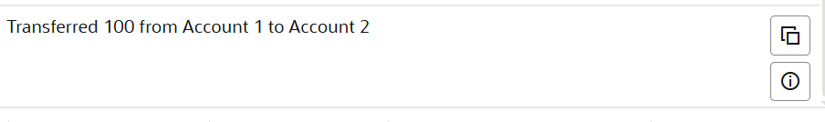

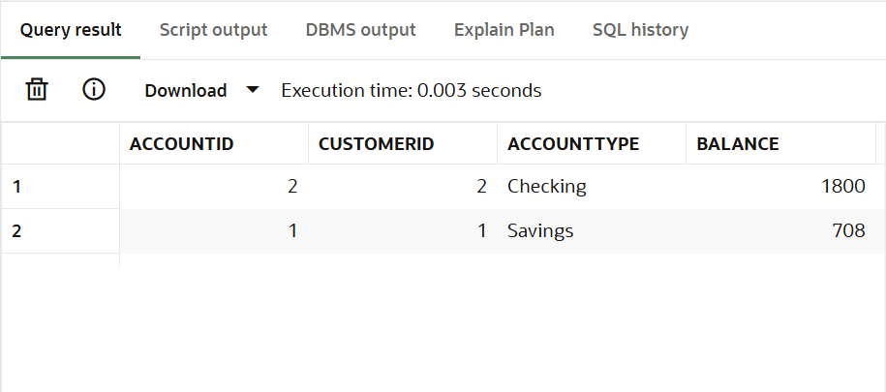

**Exercise 4: Functions**

**Scenario 1:** Calculate the age of customers for eligibility checks.

**Question:** Write a function CalculateAge that takes a customer's date of birth as input and returns their age in years.

**COMMANDS:**

CREATE OR REPLACE FUNCTION CalculateAge(p_dob DATE)

RETURN NUMBER IS

  v_age NUMBER;

BEGIN

  v_age := TRUNC(MONTHS_BETWEEN(SYSDATE, p_dob) / 12);

  RETURN v_age;

END;

/

SET SERVEROUTPUT ON;

DECLARE

  v_age NUMBER;

BEGIN

  SELECT CalculateAge(DOB) INTO v_age

  FROM Customers

  WHERE CustomerID = 999; -- Change to an existing ID

  DBMS_OUTPUT.PUT_LINE(' Age of customer 999: ' || v_age || ' years');

END;

/

SELECT

  CustomerID,

  Name,

  DOB,

  TRUNC(MONTHS_BETWEEN(SYSDATE, DOB) / 12) AS Age

FROM Customers;

OUTPUT:

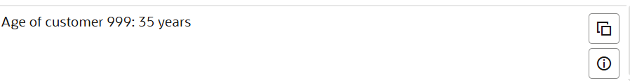

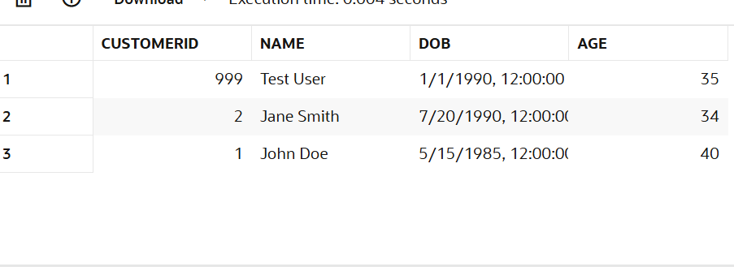

**Scenario 2:** The bank needs to compute the monthly installment for a loan.

**Question:** Write a function **CalculateMonthlyInstallment** that takes the loan amount, interest rate, and loan duration in years as input and returns the monthly installment amount.

**COMMANDS:**

CREATE OR REPLACE FUNCTION CalculateMonthlyInstallment(

  p_amount NUMBER,

  p_rate   NUMBER,

  p_years  NUMBER

) RETURN NUMBER IS

  v_monthly NUMBER;

  r NUMBER := p_rate / 12 / 100;

  n NUMBER := p_years * 12;

BEGIN

  v_monthly := (p_amount * r * POWER(1 + r, n)) /

               (POWER(1 + r, n) - 1);

  RETURN ROUND(v_monthly, 2);

END;

/

SET SERVEROUTPUT ON;

DECLARE

  v_emi NUMBER;

BEGIN

  v_emi := CalculateMonthlyInstallment(10000, 10, 2); -- 10k, 10% interest, 2 years

  DBMS_OUTPUT.PUT_LINE(' Monthly EMI: $' || v_emi);

END;

/

SELECT

  LoanID,

  CustomerID,

  LoanAmount,

  InterestRate,

  StartDate,

  EndDate

FROM Loans;

OUTPUT:



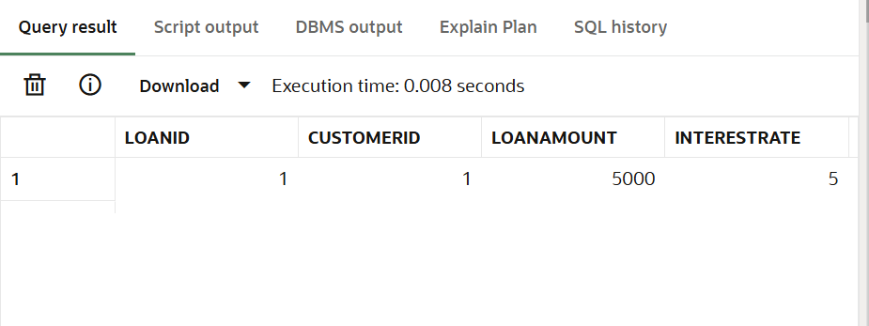

**Scenario 3:** Check if a customer has sufficient balance before making a transaction.

**Question:** Write a function **HasSufficientBalance** that takes an account ID and an amount as input and returns a boolean indicating whether the account has at least the specified amount.

**COMMANDS:**

CREATE OR REPLACE FUNCTION HasSufficientBalance(

  p_acc_id NUMBER,

  p_amount NUMBER

) RETURN BOOLEAN IS

  v_balance NUMBER;

BEGIN

  SELECT Balance INTO v_balance FROM Accounts WHERE AccountID = p_acc_id;

  RETURN v_balance >= p_amount;

EXCEPTION

  WHEN NO_DATA_FOUND THEN

    RETURN FALSE;

END;

/

SET SERVEROUTPUT ON;

DECLARE

  result BOOLEAN;

BEGIN

  result := HasSufficientBalance(1, 1000);

  IF result THEN

    DBMS_OUTPUT.PUT_LINE(' Account has sufficient balance.');

  ELSE

    DBMS_OUTPUT.PUT_LINE(' Account does NOT have sufficient balance.');

  END IF;

END;

/

SELECT

  AccountID,

  CustomerID,

  Balance,

  AccountType,

  LastModified

FROM Accounts;

**OUTPUT:**

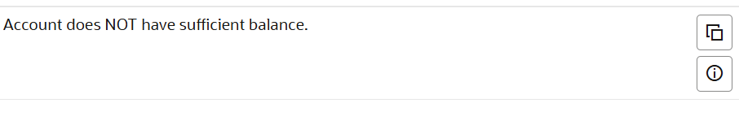

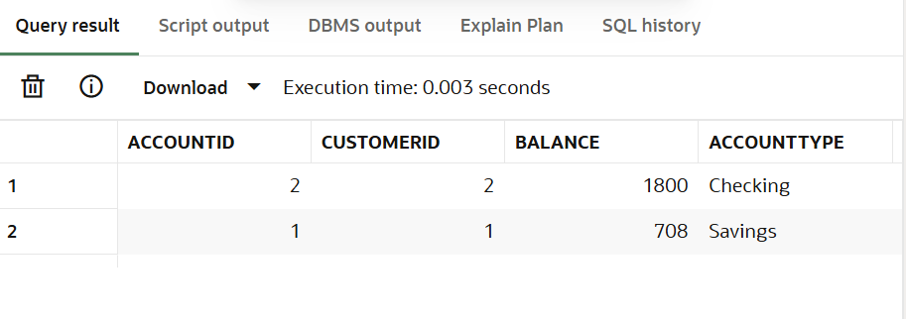

**Exercise 5: Triggers**

**Scenario 1:** Automatically update the last modified date when a customer's record is updated.

**Question:** Write a trigger **UpdateCustomerLastModified** that updates the LastModified column of the Customers table to the current date whenever a customer's record is updated.

**COMMANDS:**

CREATE OR REPLACE TRIGGER UpdateCustomerLastModified

BEFORE UPDATE ON Customers

FOR EACH ROW

BEGIN

  :NEW.LastModified := SYSDATE;

  DBMS_OUTPUT.PUT_LINE(' LastModified updated for Customer ID: ' || :NEW.CustomerID);

END;

/

SET SERVEROUTPUT ON;

UPDATE Customers

SET Name = 'Updated Name'

WHERE CustomerID = 999;

COMMIT;

SELECT CustomerID, Name, LastModified FROM Customers WHERE CustomerID = 999;

**OUTPUT:**

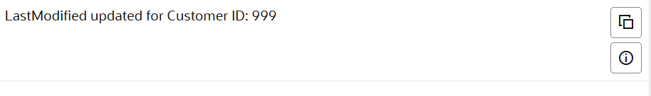

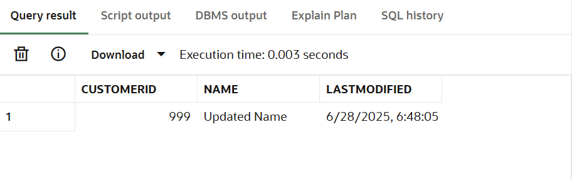

**Scenario 2:** Maintain an audit log for all transactions.

**Question:** Write a trigger **LogTransaction** that inserts a record into an AuditLog table whenever a transaction is inserted into the Transactions table.

**COMMANDS:**

CREATE TABLE AuditLog (

  AuditID NUMBER GENERATED ALWAYS AS IDENTITY PRIMARY KEY,

  AccountID NUMBER,

  Amount NUMBER,

  TransactionType VARCHAR2(10),

  LoggedAt DATE DEFAULT SYSDATE

);

CREATE OR REPLACE TRIGGER LogTransaction

AFTER INSERT ON Transactions

FOR EACH ROW

BEGIN

  INSERT INTO AuditLog (AccountID, Amount, TransactionType)

  VALUES (:NEW.AccountID, :NEW.Amount, :NEW.TransactionType);

  DBMS_OUTPUT.PUT_LINE(' Logged transaction for Account ' || :NEW.AccountID);

END;

/

SET SERVEROUTPUT ON;

INSERT INTO Transactions (TransactionID, AccountID, TransactionDate, Amount, TransactionType)

VALUES (99, 1, SYSDATE, 250, 'Deposit');

COMMIT;

SELECT * FROM AuditLog ORDER BY AuditID DESC;

**OUTPUT:**

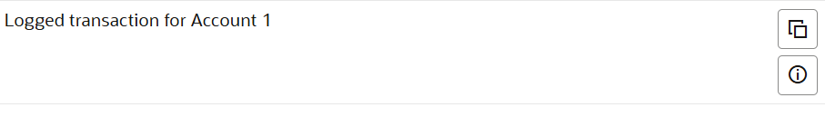 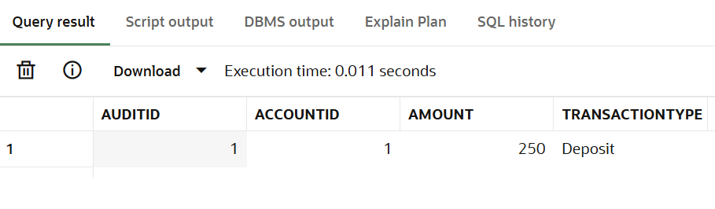

**Scenario 3:** Enforce business rules on deposits and withdrawals.

**Question:** Write a trigger **CheckTransactionRules** that ensures withdrawals do not exceed the balance and deposits are positive before inserting a record into the Transactions table.

**COMMANDS:**

CREATE OR REPLACE TRIGGER CheckTransactionRules

BEFORE INSERT ON Transactions

FOR EACH ROW

DECLARE

  v_balance NUMBER;

BEGIN

  -- Get current account balance

  SELECT Balance INTO v_balance FROM Accounts WHERE AccountID = :NEW.AccountID;

  IF :NEW.TransactionType = 'Withdrawal' AND :NEW.Amount > v_balance THEN

    RAISE_APPLICATION_ERROR(-20001, ' Withdrawal exceeds balance');

  ELSIF :NEW.TransactionType = 'Deposit' AND :NEW.Amount <= 0 THEN

    RAISE_APPLICATION_ERROR(-20002, ' Deposit amount must be positive');

  END IF;

END;

/

INSERT INTO Transactions (TransactionID, AccountID, TransactionDate, Amount, TransactionType)

VALUES (100, 1, SYSDATE, 999999, 'Withdrawal');

INSERT INTO Transactions (TransactionID, AccountID, TransactionDate, Amount, TransactionType)

VALUES (101, 1, SYSDATE, 100, 'Deposit');

COMMIT;

SELECT * FROM Transactions ORDER BY TransactionID DESC;

**OUTPUT:**

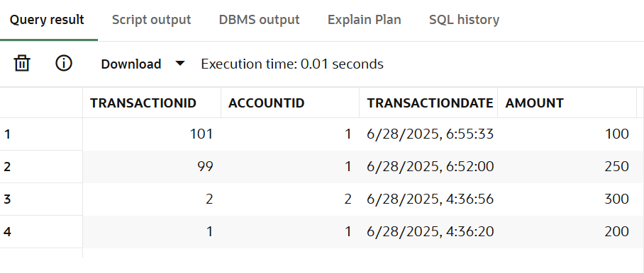

**Exercise 6: Cursors**

**Scenario 1:** Generate monthly statements for all customers.

**Question:** Write a PL/SQL block using an explicit cursor **GenerateMonthlyStatements** that retrieves all transactions for the current month and prints a statement for each customer.

**COMMANDS:**

SET SERVEROUTPUT ON;

DECLARE

  CURSOR cur_transactions IS

    SELECT t.TransactionID, c.Name AS CustomerName, t.Amount, t.TransactionDate, t.TransactionType

    FROM Transactions t

    JOIN Accounts a ON t.AccountID = a.AccountID

    JOIN Customers c ON a.CustomerID = c.CustomerID

    WHERE TO_CHAR(t.TransactionDate, 'MMYYYY') = TO_CHAR(SYSDATE, 'MMYYYY');

  rec cur_transactions%ROWTYPE;

BEGIN

  OPEN cur_transactions;

  LOOP

    FETCH cur_transactions INTO rec;

    EXIT WHEN cur_transactions%NOTFOUND;

    DBMS_OUTPUT.PUT_LINE(' Statement - ' || rec.CustomerName ||

                         ': ' || rec.TransactionType || ' of $' || rec.Amount ||

                         ' on ' || TO_CHAR(rec.TransactionDate, 'DD-Mon-YYYY'));

  END LOOP;

  CLOSE cur_transactions;

END;

/

SELECT * FROM Transactions

WHERE TO_CHAR(TransactionDate, 'MMYYYY') = TO_CHAR(SYSDATE, 'MMYYYY');

**OUTPUT:**

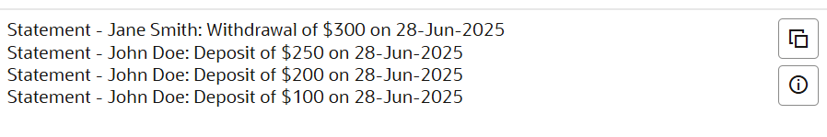

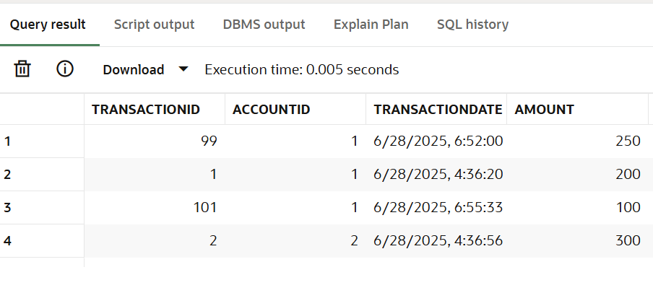

**Scenario 2:** Apply annual fee to all accounts.

**Question:** Write a PL/SQL block using an explicit cursor **ApplyAnnualFee** that deducts an annual maintenance fee from the balance of all accounts.

**COMMANDS:**

SET SERVEROUTPUT ON;

DECLARE

  CURSOR cur_accounts IS

    SELECT AccountID, Balance FROM Accounts;

  rec cur_accounts%ROWTYPE;

  fee NUMBER := 50;

BEGIN

  OPEN cur_accounts;

  LOOP

    FETCH cur_accounts INTO rec;

    EXIT WHEN cur_accounts%NOTFOUND;

    UPDATE Accounts

    SET Balance = Balance - fee

    WHERE AccountID = rec.AccountID;

    DBMS_OUTPUT.PUT_LINE('$' || fee || ' fee applied to Account ID: ' || rec.AccountID);

  END LOOP;

  CLOSE cur_accounts;

  COMMIT;

END;

/

SELECT AccountID, Balance FROM Accounts;

**OUTPUT:**

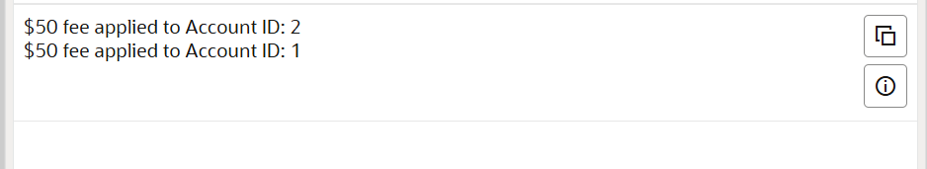

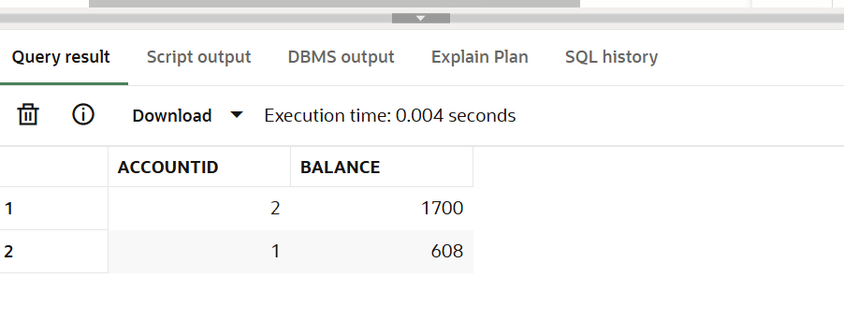

**Scenario 3:** Update the interest rate for all loans based on a new policy.

**Question:** Write a PL/SQL block using an explicit cursor **UpdateLoanInterestRates** that fetches all loans and updates their interest rates based on the new policy.

**COMMANDS:**

SET SERVEROUTPUT ON;

DECLARE

  CURSOR cur_loans IS

    SELECT LoanID, LoanAmount, InterestRate FROM Loans;

  rec cur_loans%ROWTYPE;

BEGIN

  OPEN cur_loans;

  LOOP

    FETCH cur_loans INTO rec;

    EXIT WHEN cur_loans%NOTFOUND;

    IF rec.LoanAmount > 10000 THEN

      UPDATE Loans

      SET InterestRate = InterestRate - 0.5

      WHERE LoanID = rec.LoanID;

      DBMS_OUTPUT.PUT_LINE('Interest reduced for Loan ' || rec.LoanID);

    ELSE

      UPDATE Loans

      SET InterestRate = InterestRate + 0.5

      WHERE LoanID = rec.LoanID;

      DBMS_OUTPUT.PUT_LINE('Interest increased for Loan ' || rec.LoanID);

    END IF;

  END LOOP;

  CLOSE cur_loans;

  COMMIT;

END;

/

SELECT LoanID, LoanAmount, InterestRate FROM Loans;

**OUTPUT:**

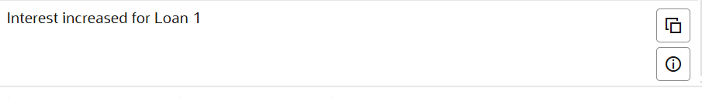

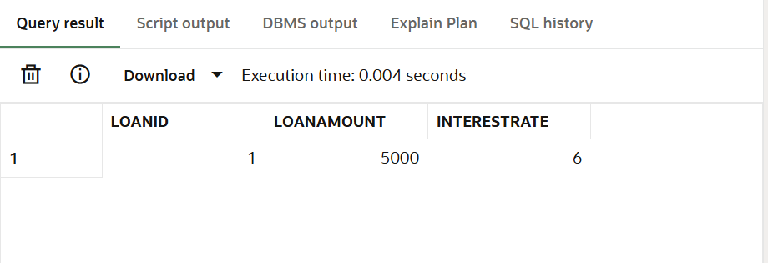

**Exercise 7: Packages**

**Scenario 1:** Group all customer-related procedures and functions into a package.

**Question:** Create a package **CustomerManagement** with procedures for adding a new customer, updating customer details, and a function to get customer balance.

**COMMANDS:**

CREATE OR REPLACE PACKAGE CustomerManagement AS

  PROCEDURE AddCustomer(p_id NUMBER, p_name VARCHAR2, p_dob DATE, p_balance NUMBER);

  PROCEDURE UpdateCustomer(p_id NUMBER, p_name VARCHAR2);

  FUNCTION GetCustomerBalance(p_id NUMBER) RETURN NUMBER;

END CustomerManagement;

/

CREATE OR REPLACE PACKAGE BODY CustomerManagement AS

  PROCEDURE AddCustomer(p_id NUMBER, p_name VARCHAR2, p_dob DATE, p_balance NUMBER) IS

  BEGIN

    INSERT INTO Customers (CustomerID, Name, DOB, Balance, LastModified)

    VALUES (p_id, p_name, p_dob, p_balance, SYSDATE);

    DBMS_OUTPUT.PUT_LINE(' Customer added: ' || p_name);

    COMMIT;

  EXCEPTION

    WHEN DUP_VAL_ON_INDEX THEN

      DBMS_OUTPUT.PUT_LINE(' Customer ID already exists.');

  END;

  PROCEDURE UpdateCustomer(p_id NUMBER, p_name VARCHAR2) IS

  BEGIN

    UPDATE Customers SET Name = p_name, LastModified = SYSDATE

    WHERE CustomerID = p_id;

    DBMS_OUTPUT.PUT_LINE(' Updated customer: ' || p_id);

    COMMIT;

  END;

  FUNCTION GetCustomerBalance(p_id NUMBER) RETURN NUMBER IS

    v_balance NUMBER;

  BEGIN

    SELECT Balance INTO v_balance FROM Customers WHERE CustomerID = p_id;

    RETURN v_balance;

  EXCEPTION

    WHEN NO_DATA_FOUND THEN

      RETURN NULL;

  END;

END CustomerManagement;

/

SET SERVEROUTPUT ON;

BEGIN

  CustomerManagement.AddCustomer(1111, 'PackageUser', TO_DATE('1995-01-01','YYYY-MM-DD'), 7000);

  CustomerManagement.UpdateCustomer(1111, 'UpdatedPackageUser');

  DBMS_OUTPUT.PUT_LINE('Balance: ' || CustomerManagement.GetCustomerBalance(1111));

END;

/

SELECT * FROM Customers WHERE CustomerID = 1111;

**OUTPUT:**

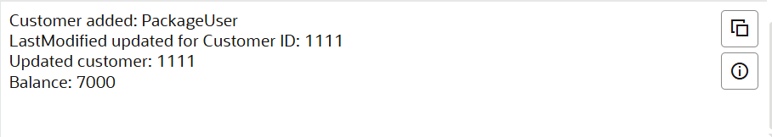

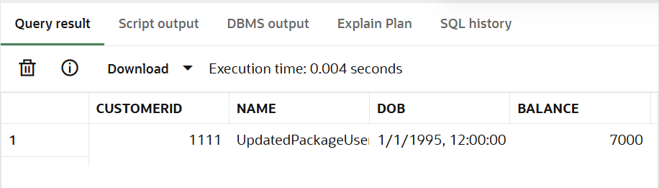

**Scenario 2:** Create a package to manage employee data.

**Question:** Write a package **EmployeeManagement** with procedures to hire new employees, update employee details, and a function to calculate annual salary.

**COMMANDS:**

CREATE OR REPLACE PACKAGE EmployeeManagement AS

  PROCEDURE HireEmployee(p_id NUMBER, p_name VARCHAR2, p_position VARCHAR2, p_salary NUMBER, p_dept VARCHAR2, p_hire DATE);

  PROCEDURE UpdateEmployee(p_id NUMBER, p_salary NUMBER);

  FUNCTION GetAnnualSalary(p_id NUMBER) RETURN NUMBER;

END EmployeeManagement;

/

CREATE OR REPLACE PACKAGE BODY EmployeeManagement AS

  PROCEDURE HireEmployee(p_id NUMBER, p_name VARCHAR2, p_position VARCHAR2, p_salary NUMBER, p_dept VARCHAR2, p_hire DATE) IS

  BEGIN

    INSERT INTO Employees VALUES(p_id, p_name, p_position, p_salary, p_dept, p_hire);

    DBMS_OUTPUT.PUT_LINE(' Hired: ' || p_name);

    COMMIT;

  END;

  PROCEDURE UpdateEmployee(p_id NUMBER, p_salary NUMBER) IS

  BEGIN

    UPDATE Employees SET Salary = p_salary WHERE EmployeeID = p_id;

    DBMS_OUTPUT.PUT_LINE(' Salary updated for Employee ID: ' || p_id);

    COMMIT;

  END;

  FUNCTION GetAnnualSalary(p_id NUMBER) RETURN NUMBER IS

    v_salary NUMBER;

  BEGIN

    SELECT Salary * 12 INTO v_salary FROM Employees WHERE EmployeeID = p_id;

    RETURN v_salary;

  EXCEPTION

    WHEN NO_DATA_FOUND THEN

      RETURN NULL;

  END;

END EmployeeManagement;

/

SET SERVEROUTPUT ON;

BEGIN

  EmployeeManagement.HireEmployee(5555, 'PackEmployee', 'Analyst', 5000, 'R&D', SYSDATE);

  EmployeeManagement.UpdateEmployee(5555, 6000);

  DBMS_OUTPUT.PUT_LINE(' Annual Salary: $' || EmployeeManagement.GetAnnualSalary(5555));

END;

/

SELECT * FROM Employees WHERE EmployeeID = 5555;

**OUTPUT:**



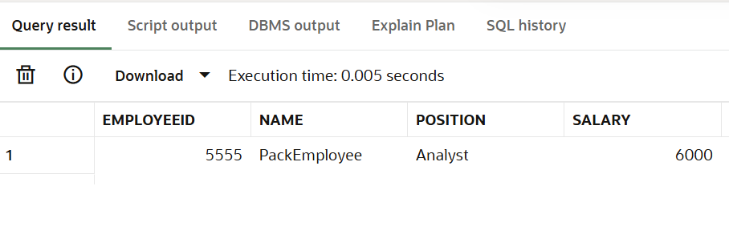

**Scenario 3:** Group all account-related operations into a package.

**Question:** Create a package **AccountOperations** with procedures for opening a new account, closing an account, and a function to get the total balance of a customer across all accounts.

**COMMANDS:**

CREATE OR REPLACE PACKAGE AccountOperations AS

  PROCEDURE OpenAccount(p_acc_id NUMBER, p_cust_id NUMBER, p_type VARCHAR2, p_balance NUMBER);

  PROCEDURE CloseAccount(p_acc_id NUMBER);

  FUNCTION GetTotalBalance(p_cust_id NUMBER) RETURN NUMBER;

END AccountOperations;

/

CREATE OR REPLACE PACKAGE BODY AccountOperations AS

  PROCEDURE OpenAccount(p_acc_id NUMBER, p_cust_id NUMBER, p_type VARCHAR2, p_balance NUMBER) IS

  BEGIN

    INSERT INTO Accounts (AccountID, CustomerID, AccountType, Balance, LastModified)

    VALUES (p_acc_id, p_cust_id, p_type, p_balance, SYSDATE);

    DBMS_OUTPUT.PUT_LINE(' Account opened: ' || p_acc_id);

    COMMIT;

  END;

  PROCEDURE CloseAccount(p_acc_id NUMBER) IS

  BEGIN

    DELETE FROM Accounts WHERE AccountID = p_acc_id;

    DBMS_OUTPUT.PUT_LINE(' Account closed: ' || p_acc_id);

    COMMIT;

  END;

  FUNCTION GetTotalBalance(p_cust_id NUMBER) RETURN NUMBER IS

    v_total NUMBER;

  BEGIN

    SELECT SUM(Balance) INTO v_total FROM Accounts WHERE CustomerID = p_cust_id;

    RETURN v_total;

  END;

END AccountOperations;

/

SET SERVEROUTPUT ON;

BEGIN

  AccountOperations.OpenAccount(2022, 999, 'Savings', 9000);

  DBMS_OUTPUT.PUT_LINE(' Total Balance for Customer 999: ' || AccountOperations.GetTotalBalance(999));

  AccountOperations.CloseAccount(2022);

END;

/

SELECT * FROM Accounts WHERE CustomerID = 999;

**OUTPUT:**

